10.2.2 Render - Blender Render Engine - Textures
Introduction to Textures 3
Material Textures 3
World Textures 5
Description 5
Brush Textures 6
Assigning a Texture 6
Choosing the Texture context 7
Choosing the Texture data type 7
Textures Slots 8
Creating a new Texture Data-Block in a new Texture Slot 8
Creating a new Texture Data-Block in a non-empty slot 8
Sharing a Texture Data-Block in a non-empty slot 8
Textures common options 9
Textures Stack 9
Texture Data-Block 9
Texture Type 10
Preview 11
Colors 11
Mapping 12
Influence 12
Texture types 12
Image Textures 15
About Image Based Texturing 16
Workflow 17
Using Images and Materials 17
Creating an Image Texture 17
Examples 18
Layering UV Textures 18
Mix and Match Materials 20
Using Alpha Transparency 21
UV Textures vs. Procedural Textures 22
Settings 23
Image Settings 23
Image Sampling 25
Image Mapping 28
Video Textures 29
Options 30
Image 30
Texture Nodes 31
Using Texture Nodes 31
Using Multiple Outputs 32
Input Nodes 32
Coordinates 34
Texture Node 35
Image Node 35
Output Nodes 35
Output 36
Viewer 36
Texture Color Nodes 36
Mix 36
RGB Curves 37
Invert 37
Hue Saturation Value 38
Combine and Separate RGB 38
Pattern Nodes 39
Checker 39
Bricks 40
Texture Nodes 41
Common Options 41
Voronoi 41
Blend 42
Magic 42
Marble 43
Clouds 44
Musgrave 46
Noise 46
Stucci 47
Distorted Noise 47
Texture Convertor Nodes 48
ColorRamp Node 49
RGB to BW Node 49
Value to Normal 50
Distance 50
Distort Nodes 50
Rotate 50
Translate 51
Scale 51
At 51
Volume Textures 52
Voxel Data 52
Settings 52
Point Density Texture 53
Options 53
Turbulence 54
Texture Mapping 55
Coordinates 55
Projection 56
Inheriting coordinates from the parent object 56
Coordinate Offset, Scaling and Transformation 57
Environment Maps 57
Options 58
Environment Map Sampling 60
Examples 61
Limitations 62
Material Textures Influence 62
Surface and Wire materials 63
Diffuse 63
Specular 63
Shading 64
Geometry 64
Other Controls 64
Volume materials 65
Halo materials 66
Texture Blending Modes 66
Bump and Normal Maps 66
Description 66
Workflow 67
Displacement Maps 68
Description 68
Options 68
Hints 69
World 69
Particles 69

Introduction to Textures

In CGI, texture mapping is a method to add detail to surfaces by projecting images and patterns onto those surfaces. The projected images and patterns can be set to affect not only color, but also specularity, reflection, transparency, and even fake 3-dimensional depth. Most often, the images and patterns are projected during render time, but texture mapping is also used to sculpt, paint and deform objects.
In Bforartists, Texture s can be:
- applied to a Material
- applied to a light, that coming from lamp
- applied to the World Background
- applied to a Brush, see for example: - Sculpting - Texture Paint
- associated with Modifiers, see: - Particles textures - Ocean textures

Material Textures
The material settings that we’ve seen so far produce smooth, uniform objects, but such objects aren’t particularly true to reality, where uniformity tends to be uncommon and out of place. In order to deal with this unrealistic uniformity, Bforartists allows the user to apply textures which can modify the reflectivity, specularity, roughness and other surface qualities of a material.
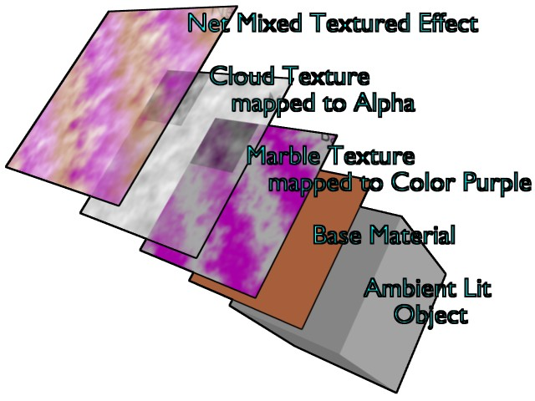
Textures Layer on base Material
Textures are like additional layers on top of the base material. Textures affect one or more aspects of the object’s net coloring. The net color you see is a sort of layering of effects, as shown in this example image. The layers, if you will, are:
- Your object, lit with ambient light based on your world settings.
- Your base material, which colors the whole surface in a uniform color that reacts to light, giving different shades of the diffuse, specular, and mirror colors based on the way light passes through and into the surface of the object.
- A primary texture layer that overlays a purple marble coloring.
- A second cloud texture that makes the surface transparent in a misty/foggy sort of way by affecting the Alpha value.
- These two textures are mixed with the base material to provide the net effect: a cube of purplish-brown fog.
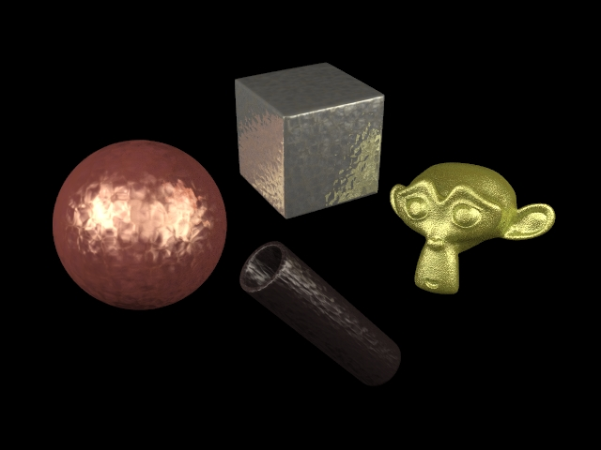
Some Metal Textures
This notion of using more than one texture, to achieve a combined effect, is one of the “hidden secrets” of creating realistic-looking objects. If you carefully “look at the light” while examining any real-life object, you will observe that the final appearance of that object is best described as the combination, in different ways and in different amounts, of several distinct underlying visual characteristics. These characteristics might be more (or less) strongly apparent at different angles, under different lighting conditions, and so forth. Bforartists allows you to achieve this in many ways. You can use “a stack of texture layers” as described in this section, or you can also use arbitrarily-complex networks (“noodles”...) of “texture nodes” as discussed here; the choice is yours.
Materials Textures fall into three primary categories:
Procedural Textures
Textures generated by a mathematical formula. For example, Wood, Clouds, and Distorted Noise
Images or Movies
Photos and films projected onto objects. For example, a flat map of Earth mapped to a sphere.
Environment Maps
Textures used to create the impression of reflections and refractions. For example, an image of a street reflected in a car window.
Data or Modifiers Textures
Textures obtained from raw data or obtained by a certain modifier in the scene. For example:
- volumetric materials use Voxel Data textures, or Point Density textures
- textures can be obtained from an Ocean Modifier
CRL 02:25, 26 May 2014 (UTC)(Sign)

World Textures
Reference
Mode: All Modes
Panel: Shading/World Context –> Preview
Hotkey:

Description
The world buttons let you set up the shading of your scene in general. It can provide ambient color, and special effects such as mist, but a very common use of a World is to shade a background color.
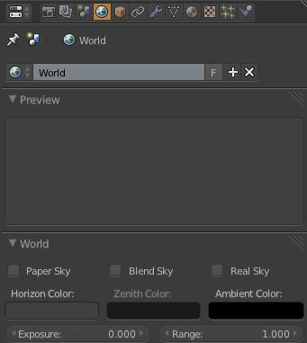
Textures Layer on base Material
HoR, HoG, HoB
The RGB color at the horizon
ZeR, ZeG, ZeB
The RGB color at the zenith (overhead)
These colors are interpreted differently, according to the Buttons in the Preview Panel (Background colors):
None Enabled
If none of these three buttons is checked, your background will just be plain flat color (using the horizon one).
Blend
The background color is blended from horizon to zenith. If only this button is pressed, the gradient runs from the bottom to the top of the rendered image regardless of the camera orientation.
Real
If this option is added, the gradient produced has two transitions, from nadir (same color as zenith) to horizon to zenith; the blending is also dependent on the camera orientation, which makes it more realistic. The horizon color is exactly at the horizon (on the x-y plane), and the zenith color is used for points vertically above and below the camera.
Paper
If this option is added, the gradient keeps its characteristics, but it is clipped in the image (it stays on a horizontal plane (parallel to x-y plane): what ever the angle of the camera may be, the horizon is always at the middle of the image).
CRL 02:31, 26 May 2014 (UTC)(Sign)

Brush Textures
Image textures can be loaded into Bforartists. These images can then be applied to a mesh model that has been unwrapped and assigned an image of user defined size.
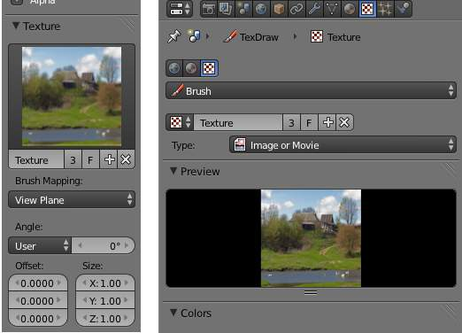
Applied Brush texture in different painting modes
- Brush textures can be used to Texture Paint textures.
- Brush textures can be used to Vertex Paint vertices.
- Brush textures can also be used in Sculpting to create topology.

Assigning a Texture

This page just shows how to add a texture to a slot. The textures’ commons options are explained here.

Choosing the Texture context
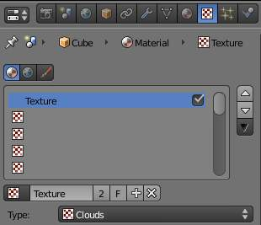
Texture panel
In the Properties editor, choose the Texture context: this will show the Texture panel.

Choosing the Texture data type
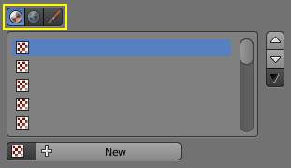
Texture panel with buttons for Material, World, and Brush textures highlighted
The three buttons Material, World, Brush at the top of the texture panel indicate the texture data type, that is, the kind of texture that is being edited.
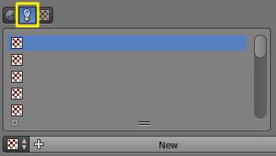
Texture panel with button for Lamp textures highlighted

Textures Slots
Texture panel
The list below these buttons represent the Stack of textures that we can manage. It can have up to eighteen Texture Slots:
- Tick or untick a texture to enable/disable it.
- Use the three buttons on the right side to move individual textures up and down in the stack or to copy/paste material’s settings between slots.

Creating a new Texture Data-Block in a new Texture Slot
Select an empty slot, then click on the New button.
This will do two things:
- it will create a new texture data-block
- also, it will add a new slot in the textures stack

Creating a new Texture Data-Block in a non-empty slot
Select a non-empty slot, then click on the Plus button.
This will do two things:
- it will create a new texture data-block, with a new name, making a copy of the texture data-block assigned to the selected slot
- it will assign this new data-block to the selected slot

Sharing a Texture Data-Block in a non-empty slot
- Select a non-empty slot, then click on the Browse button. This will open a menu showing all the available Texture data-blocks in this file.
- Choose a texture data-block in the menu to assign it to the selected slot. This will share the chosen texture with more than one object, hence the Number of users shown in the texture data-block will increase by one.

Textures common options

In the Properties editor, choose the Texture context: this will show the Texture panel.

Textures Stack
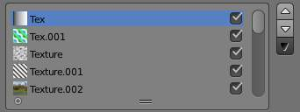
Textures Stack
The list below these buttons represents the Stack of textures that we can manage. It can have up to eighteen Texture Slots:
- Tick or untick a texture to enable/disable it.
- Use the three buttons on the right side to move individual textures up and down in the stack or to copy/paste material’s settings between slots.
The order in the Stack Textures defines how textures overlay each other for finally result image.

Texture Data-Block
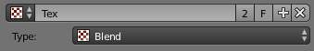
Active Texture Data-Block
Select a slot in the Textures Stack to see its settings.
The first group of buttons below the stack displays the texture currently selected in the stack.
Browse
The first button below the stack displays the all available textures in the current file. Textures are stored globally, and can be linked to more than one material. If you have already created a texture that you want to reuse, select from this list.
Name
A name field where the name of the material can be changed.
Number of users
If the active texture is used by another material, a 2 button appears that can be used to make a single-user copy of the active texture. Use this button to quickly create a new texture based on an existing texture.
Fake
The F button assigns the active texture to a “Fake” material, so that the texture is saved with the file even if it has no “real” users.
Add
Replaces the texture of the active slot with a new texture.
Unlink
Removes the texture from the active slot.

Texture Type
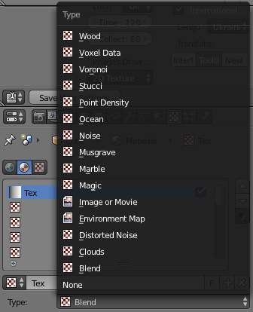
Texture Types
Choose the type of texture that is used for the current texture data-block.
- Procedural Textures
- Image and Video Textures
- Environment Map
- Volume Textures
- Ocean Texture
These types are described in detail in this section.

Preview
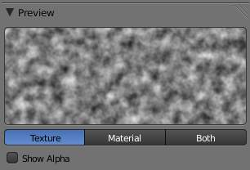
Preview panel
The texture preview panel provides a quick pre-visualisation of how the texture looks on its own, without mapping.
Texture, Material, or Both
Choose to display only the texture, only the material, or both.
Show Alpha
Show alpha in preview. If Alpha: Use is checked in the Image Sampling panel, the image’s alpha channel is displayed. If Alpha: Use is unchecked, an alpha channel based on averaged rgb values is displayed like it would be used by the Alpha slider in the Influence panel.

Colors
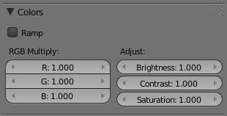
Colors panel
The Ramp button activates a color ramp which allows you to remap the colors of a texture to new ones. See Ramps for information on using ramps.
The color of a texture can be modified with the Brightness, Contrast, and Saturation buttons. All textures with RGB-Values - including Images and Environment Maps - may be modified with the RGB sliders.
R, G, B
Tint the color of a texture by brightening each red, green and blue channel.
Brightness
Change the overall brightness/intensity of the texture
Contrast
Change the contrast of the texture
Saturation
Change the saturation of the texture

Mapping
Here you can control how the texture will be mapped on the object.
Note
Brushes
These options are not available for brushes because they wouldn’t make sense

See Mapping section for details.

Influence
Here you can control what properties the texture will affect, and by how much.
They are detailed on the Influence section.
Note
Brushes
These options are not available for brushes because they wouldn’t make sense

Texture types

These are the available texture types:
- Procedural Textures
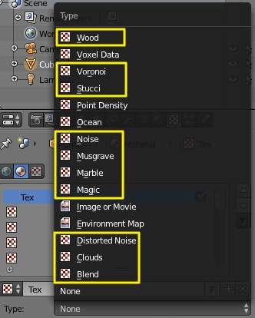
Textures generated by a mathematical formula.
- Image Textures
- Video Textures
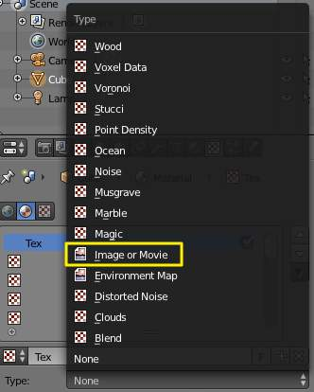
Photos and films projected onto objects.
- Combined Textures
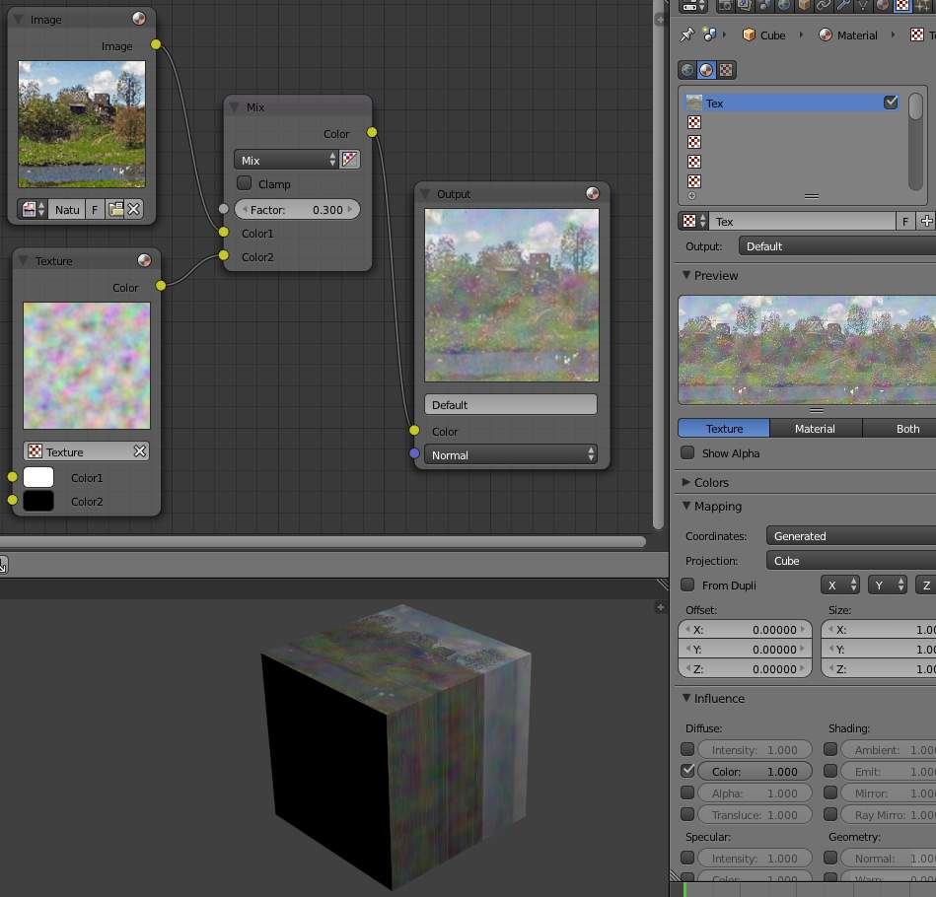
Combined textures based on nodes.
- Volume Textures
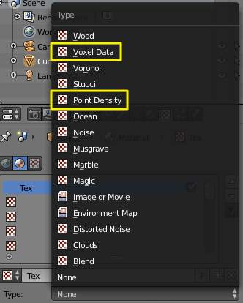
Textures that can be applied to volumetric data.
- Ocean Textures
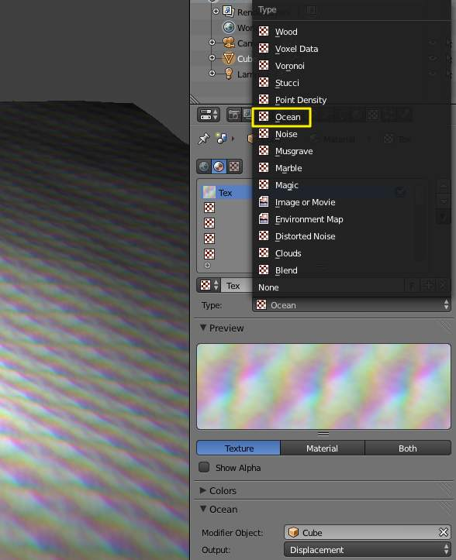
Texture generated by an Ocean modifier.

Image Textures

The term Image Texture simply means that a graphic image - a pixel grid composed of R, G, B, and sometimes Alpha values - is used as the input source to the texture. As with other types of textures, this information can be used in a number of ways, not only as a simple “decal”.
When the Texture Type Image or Movie is selected, three new panels present themselves allowing us to control most aspects of how image textures are applied: Image, Image Sampling, and Image Mapping.

About Image Based Texturing
Texture images take up precious memory space, often being loaded into a special video memory bank that is very fast and very expensive, so it is often very small. So, keep the images as small as possible. A 64x64 image takes up only one fourth the memory of a 128x128 image.
For photo-realistic rendering of objects in animations, often larger image textures are used, because the object might be zoomed in on in camera moves. In general, you want to use a texture sized proportionally to the number of pixels that it will occupy in the final render. Ultimately, you only have a certain amount of physical RAM to hold an image texture and the model and to provide work space when rendering your image.
For the most efficient memory usage, image textures should be square, with dimensions as powers of 2, such as 32x32, 64x64, 128x128, 256x256, 1024x1024, 2048x2048, and 4096x4096.
If you can re-use images across different meshes, this greatly reduces memory requirements. You can re-use images if you map those areas of the meshes that “look alike” to a layout that uses the common image. In the overview below, the left image is re-used for both the sphere and a portion of the monkey. The monkey uses two layouts, one which has one UV map of a few faces, and another that has three maps.
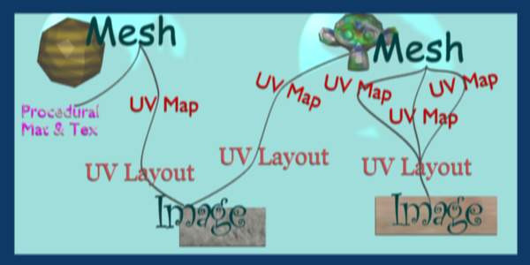
How all the parts of UV Texturing work together
When using file textures, it is very important that you have Mapped the UVs of the mesh, and they are laid out appropriately.
You don’t have to UV map the entire mesh. The sphere above on the left has some faces mapped, but other faces use procedural materials and textures. Only use UV Textures for those portions of your mesh where you want very graphic, precise detail. For example, a model of a vase only needs UV Texture for the rim where decorative artwork is incorporated. A throw pillow does not need a different image for the back as the front; in fact many throw pillows have a fabric (procedural material) back.
As another example, you should UV map both eyes of a head to the same image (unless you want one bloodshot and the other clear). Mapping both sides of a face to the same image might not be advisable, because the location of freckles and skin defects are not symmetrical. You could of course change the UV map for one side of the face to slightly offset, but it might be noticeable. Ears are another example where images or section of an images can be mapped to similar faces.

Workflow
The process consists of the following steps.
- Create the Mesh. Unwrap it into one or more UV Layouts.
- Create one or more Materials for the Mesh.
- Create one or more images for each UV Layout and aspect of the texture. Either - paint directly on the mesh using Texture Paint in the 3D window, - load and/or edit an image in the UV Editor window, or - Bake the existing materials into an image for the UV Editor window.
- Apply those images as UV Textures to the mesh to affect one or more aspects of the mesh. This is done by using one or more of the numerous Map To options. For example, - map to Color to affect the diffuse coloring of the mesh, - map to Nor to affect the normal direction to give the surface a bumpy or creased look, or - map to Spec (specularity) to make certain areas look shiny and oily.
- Layer the Textures to create a convincing result.

Using Images and Materials
To use an image as the color and alpha (transparency) of the texture, you can create an image in an external paint program and tell the UV/Image Editor to Open that file as the texture, or you can create a New image and save it as the texture.
If you want to start off by creating an image using an external paint program, you will want to save an outline of your UV faces by using the Save UV Face Layout tool located in the UVs menu. This is discussed here.

Creating an Image Texture
To create an image within Bforartists, you have to first create a New Blank Image with a uniform color or test grid. After that, you can color the image using the:
- Vertex colors as the basis for an image
- Render Bake image based on how the mesh looks in the scene
After you have created your image, you can modify it using Bforartists’s built-in Texture Paint or any external image painting program.
Note
See Texture in 3D View but does not Render
You may be able to see the texture in Textured display mode in the 3D View; this is all that is required to have textures show up in Bforartists’s Game Engine. Rendering, however, requires a material. You must have a Face Textures material assigned to the mesh for it to render using the UV Texture. In the Material settings, ADD NEW material to a selected object and enable Face Textures.

Examples
There may be one UV Layout for the face of a character, and another for their clothes. Now, to texture the clothes, you need to create an image at least for the Color of the clothes, and possible a “bump” texture to give the fabric the appearance of some weave by creating a different image for the Normal of the clothes. Where the fabric is worn, for example at the elbows and knees, the sheen, or Specularity, of the fabric will vary and you will want a different image that tells Bforartists how to vary the Specularity. Where the fabric is folded over or creased, you want another image that maps Displacement to the mesh to physically deform the mesh. Each of these are examples of applying an image as a texture to the mesh.
As another example, the face is the subject of many questions and tutorials. In general, you will want to create a Material that has the basic skin color, appropriate shaders, and sub-surface scattering. Then you will want to layer on additional UV Textures for:
- Freckle map for Color and Normal aspects
- Subdermal veins and tendons for Displacement
- Creases and Wrinkles and skin cell stratification for Normal
- Makeup images for Color
- Oily maps for Specularity
- For a zombie, Alpha transparency where the flesh has rotted away (ewwww....)
- Under chin and inside nostrils that receive less Ambient light
- Thin skin is more translucent, so a map is needed for that
Each image is mapped by using another Texture Channel. Each of these maps are images which are applied to the different aspects (Color, Normal, Specularity) of the image. Tileable images can be repeated to give a smaller, denser pattern by using the Texture controls for repeat or size.

Layering UV Textures
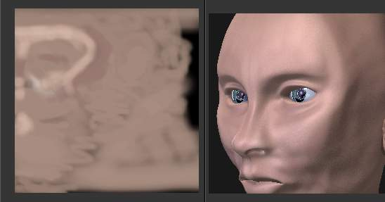
Base UV Texture
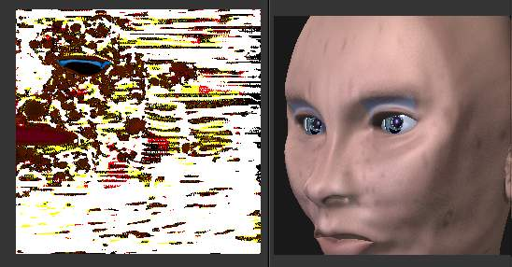
Layered UV Texture
Great textures are formed by layering images on top of one another. You start with a base layer, which is the base paint. Each successive layer on top of that is somewhat transparent to let the bottom layers show through, but opaque where you want to add on to details.
To avoid massive confusion, all image textures for a mesh usually use the same UV map. If you do, each image will line up with the one below it, and they will layer on top of one another like the examples shown to the right. To do this, just create one UV Texture (map) as described in this section. Then, create material image textures as described in the procedural materials section. Instead of mapping to Original Coordinates (OrCo), map to UV.
Use that map name repeatedly in the Material–>Textures–>Map Input panel by selecting UV and typing the name in the text field. In the example to the right, our UV Texture is called “Head” (you may have to expand the image to see the panel settings). Then, the image texture shown will be mapped using the UV coordinates. In the “Base UV Texture” example to the right, the face has two textures UV mapped; one for a base color, and another for spots, blemishes and makeup.
Both textures use the same UV Texture map as their Map Input, and both affect Color. The Makeup texture is transparent except where there is color, so that the base color texture shows through. Note that the colors were too strong on the image, so they amount of Col affects is turned down to 60% in the second layer (the blemish layer).
Normally, we think of image textures affecting the color of a mesh. Realism and photo-realistic rendering is a combination of many different ways that light interacts with the surface of the mesh. The image texture can be Mapped To not only color, but also Normal (bumpiness) or Reflection or any of the other attributes specified in the Map To panel.
If you paint a grey-scale image (laid out according to the UV Layout) with white where the skin is oily and shiny, and dark where it is not, you would map that input image according to the UV Layout, but have it affect Specularity (not color).
To make portions of a mesh transparent and thus reveal another mesh surface underneath, you would paint a grey-scale image with black where you want the texture transparent, map input to UV, and map it to Alpha (not color). To make portions of a mesh, like a piece of hot metal, appear to glow, you would use a grey-scale image mapped to Emit.
Believe it or not, this is only “the tip of the iceberg!” If everything that’s been described here just isn’t enough for you, the texture nodes feature, introduced in recent versions of Bforartists, enables you to layer and combine textures in almost any way you can imagine.

Mix and Match Materials
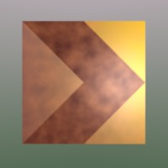
You can mix and match procedural materials and textures, vertex paint, and UV textures onto the same mesh.
The image to the right has a world with a red ambient light. The material has both VCol Paint and Face Textures enabled, and receives half of ambient light. A weak cloud texture affects color, mixing in a tan color. The right vertices are vertex painted yellow and the left is unpainted procedural gray. The UV Texture is a stock arrow image from the public domain texture CD. Scene lighting is a white light off to the right. From this information and the User Manual thus far, you should now be able to recreate this image.
You can also assign multiple materials to the mesh based on which faces you want to be procedural and which you want to be texture-mapped. Just don’t UV map the faces you want to be procedural.
You can use UV Textures and VertexPaint (V in the 3D View window) simultaneously, if both are enabled in the Material settings. The vertex colors are used to modulate the brightness or color of the UV image texture:
- UV Texture is at the base (Face Textures)
- Vertex paint affects its colors, then
- Procedural textures are laid on top of that,
- Area lights shine on the surface, casting shadows and what not, and finally
- Ambient light lights it up.
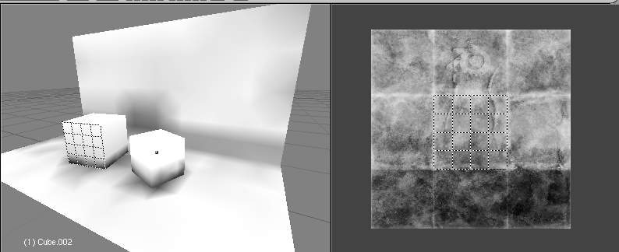
Vertex colors modulate texture.
A UV Layout can only have one image, although you can tile and animate the image. Since a layout is a bunch of arranged UV Maps, and a UV Map maps many mesh faces, a face can therefore only have one UV Texture image, and the UV coordinates for that face must fit entirely on the image. If you want a face to have multiple images, split the face into parts, and assign each part its own image. (Or you can get fancy with Nodes, but that’s another story ...)

Using Alpha Transparency
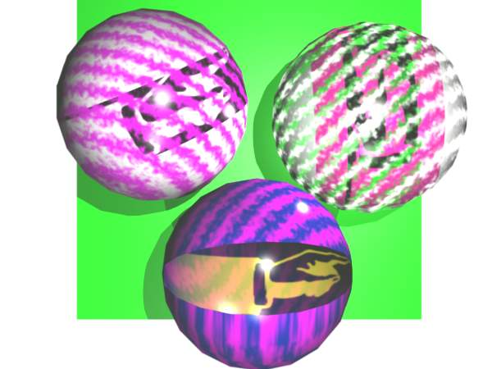
Alpha UV Textures
Alpha 0.0 (transparent) areas of a UV Image render as black. Unlike a procedural texture, they do not make the base material transparent, since UV Textures do not operate on the base procedural material. The UV texture overrides any procedural color underneath. Procedural Textures are applied on top of UV Textures, so a procedural image texture would override any UV Texture. Transparent (black) areas of a procedural texture mapped to alpha operate on top of anything else, making the object transparent in those places. The only thing that modulates visible parts of a UV Texture are the Vertex Colors. In the example to the right, the finger image is transparent at the cuff and top of the finger and is used as a UV Texture. All three balls have a base material of blue and a marbling texture. The base material color is not used whenever Face Textures is enabled.
The top left ball has not had any vertex painting, and the finger is mapped to the middle band, and the texture is mapped to a pink color. As you can see, the base material has VCol Paint and Face Textures enabled; the base color blue is not used, but the texture is. With no vertex painting, there is nothing to modulate the UV Texture colors, so the finger shows as white. Transparent areas of the UV Image show as black.
The top right ball has had a pink vertex color applied to the vertical band of faces (in the 3D View window, select the faces in UV Paint mode, switch to Vertex Paint mode, pick a pink color, and Paint–>Set Vertex Colors). The finger is mapped to the middle vertical band of faces, and VCol and Face Textures are enabled. The texture is mapped to Alpha black and multiplies the base material alpha value which is 1.0. Thus, white areas of the texture are 1.0, and 1.0 times 1.0 is 1.0 (last time I checked, at least), so that area is opaque and shows. Black areas of the procedural texture, 0.0, multiply the base material to be transparent. As you can see, the unmapped faces (left and right sides of the ball) show the vertex paint (none, which is gray) and the painted ones show pink, and the middle stripe that is both painted and mapped change the white UV Texture areas to pink. Where the procedural texture says to make the object transparent, the green background shows through. Transparent areas of the UV Texture insist on rendering black.
The bottom ball uses multiple materials. Most of the ball (all faces except the middle band) is a base material that does not have Face Textures (nor Vertex Color Paint - VCol Paint) enabled. Without it enabled, the base blue material color shows and the pink color texture is mixed on top. The middle band is assigned a new material (2 Mat 2) that does have vertex paint and Face Textures enabled. The middle band of faces were vertex painted yellow, so the white parts of the finger are yellow. Where the pink texture runs over the UV texture, the mixed color changes to green, since pink and yellow make a green.
If you want the two images to show through one another, and mix together, you need to use Alpha. The base material can have an image texture with an Alpha setting, allowing the underlying UV Texture to show through.
To overlay multiple UV images, you have several options:
- Create multiple UV Textures which map the same, and then use different images (with Alpha) and Bforartists will overlay them automatically.
- Use the Composite Nodes to combine the two images via the AlphaOver node, creating and saving the composite image. Open that composited image as the UV Texture.
- Use an external paint program to alpha overlay the images and save the file, and load it as the face’s UV Texture
- Define two objects, one just inside the other. The inner object would have the base image, and the outer image the overlaid image with a material alpha less than one (1.0).
- Use the Material nodes to combine the two images via the AlphaOver or Mix node, thus creating a third noded material that you use as the material for the face. Using this approach, you will not have to UV map; simply assign the material to the face using the Multiple Materials

UV Textures vs. Procedural Textures
A Material Texture, that has a Map Input of UV, and is an image texture that is mapped to Color, is equivalent to a UV Texture. It provides much more flexibility, because it can be sized and offset, and the degree to which it affects the color of your object can be controlled in the Map To panel. In addition, you can have different images for each texture channel; one for color, one for alpha, one for normals, one for specularity, one for reflectivity, etc. Procedural textures, like Clouds, are INCREDIBLY simple and useful for adding realism and details to an image.
UV Texture | Procedural Texture
Image maps to precise coordinates on the selected faces of the mesh | Pattern is generated dynamically, and is mapped to the entire mesh (or portion covered by that material)
The Image maps once to a range of mesh faces specifically selected | Maps once to all the faces to which that material is assigned; either the whole mesh or a portion
Image is mapped once to faces. | Size XYZ in the MapInput allows tiling the texture many times across faces. Number of times depends on size of mesh
Affect the color and the alpha of the object. | Can also affect normals (bumpiness), reflectivity, emit, displacement, and a dozen other aspects of the mesh’s appearance; can even warp or stencil subsequent textures.
Can have many for a mesh | Can be layered, up to 10 textures can be applied, layering on one another. Many mix methods for mixing multiple channels together.
Any Image type (still, video, rendered). Preset test grid available | Many different presents: clouds, wood grain, marble, noise, and even magic.
Provides the UV layout for animated textures | Noise is the only animated procedural texture
Takes very limited graphics memory | Uses no or little memory; instead uses CPU compute power
So, in a sense, a single UV texture for a mesh is simpler but more limited than using multiple textures (mapped to UV coordinates), because they do one specific thing very well: adding image details to a range of faces of a mesh. They work together if the procedural texture maps to the UV coordinates specified in your layout. As discussed earlier, you can map multiple UV textures to different images using the UV Coordinate mapping system in the Map Input panel.

Settings

Image Settings
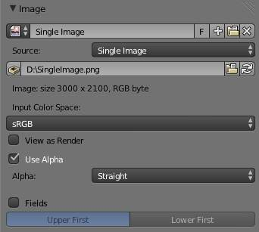
Image panel
In the Image Sampling panel we tell Bforartists which source file to use.
Image or Movie Data-block:
Browse
Select an image or video among linked to the .blend file
Name field
Internal name of image
F
Create a fake user for the image texture
+
Replace active texture with a new one
Folder
Browse for an image on your computer
X
Unlink this image or movie.
Source:
Where the image come from. What kind of source file to use.
Generated
Generated image in Bforartists.
Movie
Movie file.
Image Sequence
Multiple image files as a sequence.
Single Image
Single image file.
File for Image or Movie texture:
See about supported Image formats.
Pack image
Embed image into current .blend file
Path
Path to file
File Browser
Find a file on your computer. Hold Shift to open the selected file and Ctrl to browse a containing directory.
Reload
Reloads the file. Useful when an image has been rework in an external application.
Input Color Space
Color space of the image or movie on disk
XYZ
XYZ space.
VD16
The simple video conversion from a gamma 2.2 sRGB space.
sRGB
Standart RGB display space.
Raw
Raw space.
Non-Color
Color space used for images which contains non-color data (i.e. normal maps).
Linear ACES
ACES linear space.
Linear
709 (full range). Bforartists native linear space.
View as Render
Apply render part of display transformation when displaying this image on the screen.
Use Alpha
Use the alpha channel information from the image or make image fully opaque
Straight
Transparent RGB and alpha pixels are unmodified.
Premultiplied
Transparent RGB pixels of an image are multiplied by the image’s alpha value.
Fields
Work with field images. Video frames consist of two different images (fields) that are merged. This option ensures that when Fields are rendered, the correct field of the image is used in the correct field of the rendering. MIP Mapping cannot be combined with Fields.
Upper First
Order of video fields - upper field first.
Lower First
Order of video fields - lower field first.
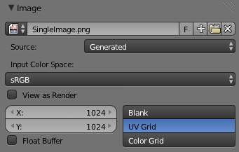
Image panel for Generated source of Image texture
For Generated source there are the specific options: X and Y size
Width and height of image to be generated.
Generated Image Type
Which kind of image to be generated
Blank
Generate a blank image.
UV Grid
Generated grid to test UV mappings.
Color Grid
Generated improved UV grid to test UV mappings.
Float Buffer
Generate floating point buffer.
About specific options for movie and image sequence source. see here

Image Sampling
In the Image Sampling panel we can control how the information is retrieved from the image.
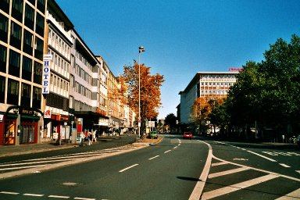 | 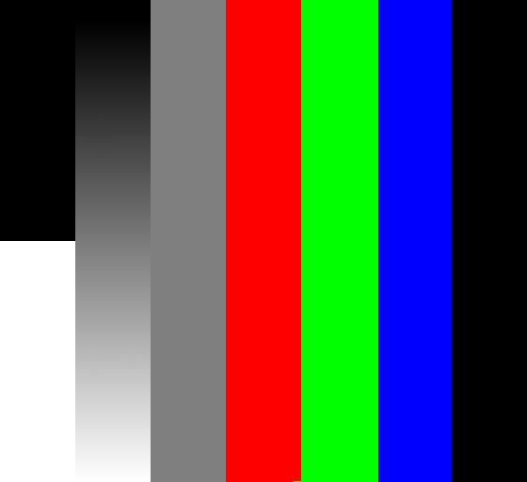
Background image | Foreground image
The two images presented here are used to demonstrate the different image options. The background image is an ordinary JPG-file, the foreground image is a PNG-file with various alpha and greyscale values. The vertical bar on the right side of the foreground image is an Alpha blend, the horizontal bar has 50% alpha.
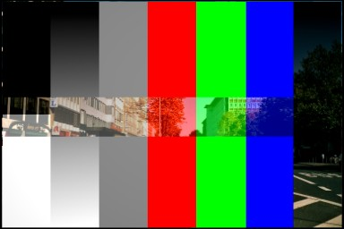 | 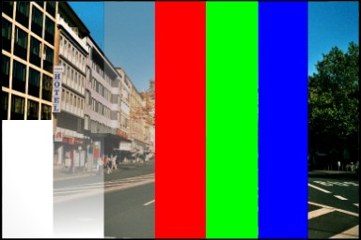
Foreground image with Use alpha. The alpha values of the pixels are evaluated | Foreground image with Calculate alpha
Alpha
Options related to transparency
Use
Works with PNG and TGA files since they can save transparency information (Foreground Image with UseAlpha). Where the alpha value in the image is less than 1.0, the object will be partially transparent and stuff behind it will show.
Calculate
Calculate an alpha based on the RGB values of the Image. Black (0,0,0) is transparent, white (1,1,1) opaque. Enable this option if the image texture is a mask. Note that mask images can use shades of gray that translate to semi-transparency, like ghosts, flames, and smoke/fog.
Invert
Reverses the alpha value. Use this option if the mask image has white where you want it transparent and vice-versa.
Flip X/Y Axis
Rotates the image 90 degrees counterclockwise when rendered.
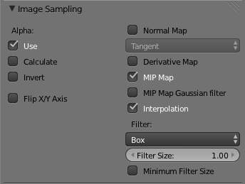
Image Sampling panel
Normal Map
This tells Bforartists that the image is to be used to create the illusion of a bumpy surface, with each of the three RGB channels controlling how to fake a shadow from a surface irregularity. Needs specially prepared input pictures. See Bump and Normal Maps.
Normal Map Space:
Tangent: Object: World: Camera:
Derivative Map
Use red and green as derivative values.
MIP Map
MIP Maps are pre-calculated, smaller, filtered Textures for a certain size. A series of pictures is generated, each half the size of the former one. This optimizes the filtering process. By default, this option is enabled and speeds up rendering (especially useful in the game engine). When this option is OFF, you generally get a sharper image, but this can significantly increase calculation time if the filter dimension (see below) becomes large. Without MIP Maps you may get varying pictures from slightly different camera angles, when the Textures become very small. This would be noticeable in an animation.
MIP Map Gaussian filter
Used in conjunction with MIP Map, it enables the MIP Map to be made smaller based on color similarities. In the game engine, you want your textures, especially your MIP Map textures, to be as small as possible to increase rendering speed and frame rate.

Enlarged Image texture without and with Interpolation
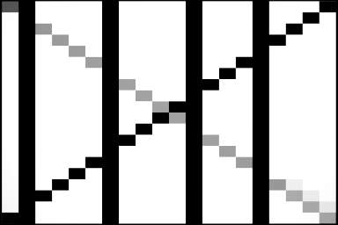 | 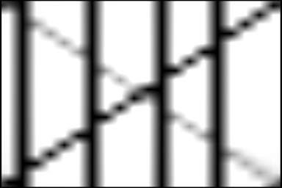
Interpolation
This option interpolates the pixels of an image. This becomes visible when you enlarge the picture. By default, this option is on. Turn this option OFF to keep the individual pixels visible and if they are correctly anti-aliased. This last feature is useful for regular patterns, such as lines and tiles; they remain ‘sharp’ even when enlarged considerably. When you enlarge this 10x10 pixel Image
the difference with and without Interpolation is clearly visible. Turn this image off if you are using digital photos to preserve crispness.
Filter
The filter size used in rendering, and also by the options MipMap and Interpolation. If you notice gray lines or outlines around the textured object, particularly where the image is transparent, turn this value down from 1.0 to 0.1 or so.
Texture Filter Type
Texture filter to use for image sampling. Just like a pixel represents a pic ture el ement, a texel represents a tex ture el ement. When a texture (2D texture space) is mapped onto a 3D model (3D model space), different algorithms can be used to compute a value for each pixel based on samplings from several texels.
Box
A fast and simple nearest-neighbor interpolation known as Monte Carlo integration
EWA (Elliptical Weighted Average)
One of the most efficient direct convolution algorithms developed by Paul Heckbert and Ned Greene in the 1980s. For each texel, EWA samples, weights, and accumulates texels within an elliptical footprint and then divides the result by the sum of the weights.
Eccentricity
Maximum Eccentricity. Higher values give less blur at distant/oblique angles, but is slower
FELINE (Fast Elliptical Lines)
Uses several isotropic probes at several points along a line in texture space to produce an anisotropic filter to reduce aliasing artifacts without considerably increasing rendering time.
Probes
Number of probes to use. An integer between 1 and 256. Further reading: McCormack, J; Farkas, KI; Perry, R; Jouppi, NP (1999) Simple and Table Feline: Fast Elliptical Lines for Anisotropic Texture Mapping, WRL
Area
Area filter to use for image sampling
Eccentricity
Maximum Eccentricity. Higher values give less blur at distant/oblique angles, but is slower
Filter Size
The filter size used by MIP Map and Interpolation
Minimum Filter Size
Use Filter Size as a minimal filter value in pixels

Image Mapping
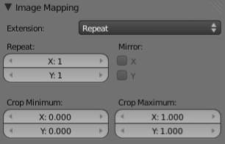
Image Mapping panel
In the Image Mapping panel, we can control how the image is mapped or projected onto the 3D model.
Extension:
Extend
Outside the image the colors of the edges are extended
Clip
Clip to image size and set exterior pixels as transparent. Outside the image, an alpha value of 0.0 is returned. This allows you to ‘paste’ a small logo on a large object.
Clip Cube
Clips to cubic-shaped area around the images and sets exterior pixels as transparent. The same as Clip, but now the ‘Z’ coordinate is calculated as well. An alpha value of 0.0 is returned outside a cube-shaped area around the image.
Repeat
The image is repeated horizontally and vertically
Repeat
X/Y repetition multiplier
Mirror
Mirror on X/Y axes. This buttons allow you to map the texture as a mirror, or automatic flip of the image, in the corresponding X and/or Y direction.
Checker
Checkerboards quickly made. You can use the option size on the Mapping panel as well to create the desired number of checkers.
Even / Odd
Set even/odd tiles
Distance
Governs the distance between the checkers in parts of the texture size
Crop Minimum / Crop Maximum
The offset and the size of the texture in relation to the texture space. Pixels outside this space are ignored. Use these to crop, or choose a portion of a larger image to use as the texture.

Video Textures

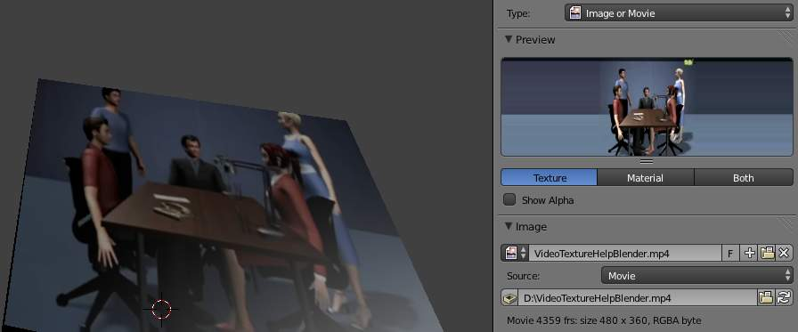
Video texture
Video textures are a some kind of Image textures and based on movie file or sequence of successive numbered separate images. They are added in the same way that image textures are.

Options

Image
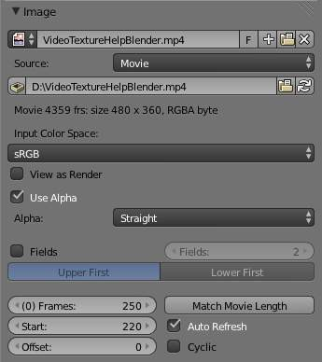
Image panel for video texture
Source
For video texture the kind of source file to use is
Movie
See about supported Movie formats.
Image Sequence
See about supported Image formats. To load image sequence in any of the supported image file formats first click on the first frame and then Accept. Then change the Source to Image Sequence, and enter the ending frame number of this sequence.
More about loading source file for video texture see here.
Fields
Work with field images. Video frames consist of two different images (fields) that are merged. This option ensures that when Fields are rendered, the correct field of the image is used in the correct field of the rendering.
Upper First
Order of video fields - upper field first.
Lower First
Order of video fields - lower field first.
Fields
Number of fields per rendered frame. Used with Fields and interlaced video, it says whether each image has both odd and even, or just one.
Frames
Number of frames/images in the movie or sequence to use
Start
Global starting frame of the sequence/movie
Offset
Offset the number of the frame to use in the animation. What frame number inside the movie/sequence to start grabbing.
Match Movie Length
This button set image’s user’s length to the one of selected movie/sequence.
Auto Refresh
Automatically refresh images on frame changes
Cyclic
When the video ends, it will loop around the to the start and begin playing again.
For Movie source:
Use Alpha
Use the alpha channel information from the image or make image fully opaque
Straight
Transparent RGB and alpha pixels are unmodified.
Premultiplied
Transparent RGB pixels of an image are multiplied by the image’s alpha value.
See also
For sampling and mapping documentation see Image Texture

Texture Nodes

As an alternative to using the Texture Stack, Bforartists includes a node-based texture generation system which enables you to create textures by combining colors, patterns and other textures in much the same way that you combine Material Nodes.
You can use these textures wherever you can use regular textures: you can place them in texture channels, in material nodes, in particle systems, and even inside other textures.
Note
Node-based textures do not work for realtime display, they will only be visible in rendered images.

Using Texture Nodes
To use texture nodes with the current texture, open a Node Editor window, set it to Texture mode by clicking the “Texture” icon (
Texture
) in its header.
To start adding nodes, you first need to select a material. Now you can either click the New button in the Node editor, or the New button in the texture panel. Once you have a texture selected, you can toggle it to function as a regular texture or a node texture by clicking the Use Nodes option in the Node Editor.
The default node setup will appear: a red-and-white checkerboard node connected to an Output named Default. For texture nodes, you can create as many Outputs as you like in your node setup. (Other types of node networks, as you may recall, are limited to only one Output node.) See the next section for details.
For instructions on how to add, remove and manipulate the nodes in the tree, see the Node Editor manual.

Using Multiple Outputs
Each texture that you define with Texture Nodes can have several outputs, which you can then use for different things. For example, you might want your texture to define both a diffuse (color) map and a normal map. To do this, you would:
- Create two texture slots in the texture list, and set them to the same texture data-block.
- Add two Output nodes to the node tree, and type new names into their Name text-boxes: e.g. Diffuse for one and Normal ” for the other.
- Underneath the texture picker in the texture panel, you’ll see a dropdown list with the names of your outputs. For each entry in the texture list, select the desired output by changing the menu entry e.g. set on to Diffuse and the other to Normal).
You can also use these named outputs if you’ve decided to define your material using Material Nodes. In this case, you probably won’t be using Texture Channels. Instead, you’ll insert Texture nodes into your Material Node tree using Add –> Input –> Texture. Then, inside the texture node that you’ve just added, you can select which output you want to use (e.g. Diffuse or Normal).

Input Nodes

Input nodes provide input data for other nodes.
Time

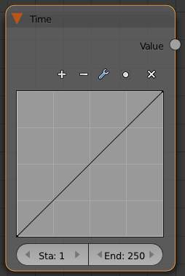
Time node
The time node uses a frame range to output a value between 0 and 1. By default the node output a linear transition from 0 to 1 from frame 1 to 250. The shape of the curve can be manipulated to vary the output over time in different ways.
Plus:Zoom in. Minus:Zoom out Tools:
Reset View
Resets curve view
Vector Handle
Breaks tangent at curve handle, making a angle.
Auto Handle
Default smooth interpolation of curve segments
Extend Horizontal
Causes the curve to stay horizontal before the first point and after the last point.
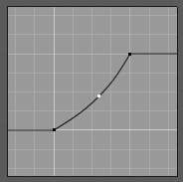
Extend Horizontal
Extend Extrapolated
Causes the curve to extrapolate before the first point and after the last point, based on the shape of the curve.
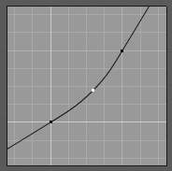
Extend Extrapolate
Reset Curve
Resets shape of curve to original linear shape.
Clipping Options:
Use Clipping
Forces curve points to stay between specified values.
Min X/Y and Max X/Y
Set the minimum and maximum bounds of the curve points.
X:Delete curve points. The first and last points cannot be deleted. X and Y The coordinates of the selected edit point. Sta:Specify the start frame to use. End:Specify the end frame to use.

Coordinates
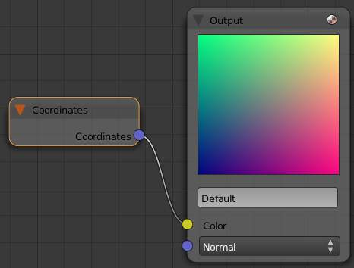
Coordinates node
The Coordinates node outputs the geometry local coordinates, relative to its bounding box as RGB colors:
- Red channel corresponds to X value.
- Green channel corresponds to Y value.
- Green channel corresponds to Z value.

Texture Node
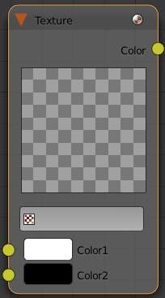
Texture node
The texture node can be used to load a another node based or non-node based texture.
Color 1 and Color 2
These can be used to remap a greyscale texture using two colors.

Image Node
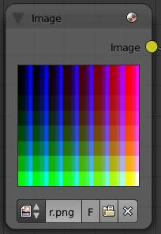
Image node
The image node can be used to load an external image.
Browse for image
Select an image that already exists in the scene.
Data-block name
Set the name of the image data-block.
F
Save this image data-block, even if it has no users.
Open image
Select image to use from file browser.
Unlink data-block
Remove the image data-block from the node.

Output Nodes

These node serves a outputs for node textures

Output
This node contains the result of the node texture. Multiple output nodes can exist in a node texture, however only one of them is active. The active one is set in the Texture Panel in the Output drop down.
Color
The color data that the texture renders
Normal
The normal map that the texture will output.

Viewer
The viewer node can be used to preview the results of a node.

Texture Color Nodes

Mix
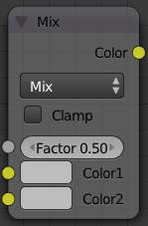
mix node
This node mixes a base color or image (threaded to the top socket) together with a second color or image (bottom socket) by working on the individual and corresponding pixels in the two images or surfaces. The way the output image is produced is selected in the drop-down menu. The size (output resolution) of the image produced by the mix node is the size of the base image. The alpha and Z channels (for compositing nodes) are mixed as well.
See also
Color Blend Modes for details on each blending mode.

Note
Color Channels
There are two ways to express the channels that are combined to result in a color: RGB or HSV. RGB stands for the Red,Green,Blue pixel format, and HSV stands for Hue,Saturation,Value pixel format.

Clamp
Clamps the result of the mix operation between 0 and 1. Some of the mix types can produce reults above 1 even if the inputs are both between 0 and 1, such as Add.
Factor
The amount of mixing of the bottom socket is selected by the Factor input field (Fac:). A factor of zero does not use the bottom socket, whereas a value of 1.0 makes full use. In Mix mode, 0.5 is an even mix between the two, but in Add mode, 0.5 means that only half of the second socket’s influence will be applied.

RGB Curves
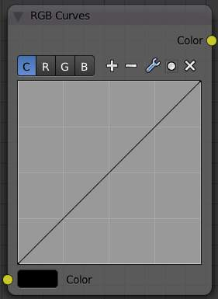
RGB Curves node
For each color component channel (RGB) or the composite (C), this node allows you to define a bezier curve that varies the input (x-axis) to produce an output value (y-axis). Clicking on one of the C R G B components displays the curve for that channel.
See also
- Read more about using the Curve Widget.
- RGB Curves node in the compositor (includes examples)

Invert
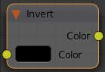
invert node
This node simply inverts the input values and colors.

Hue Saturation Value
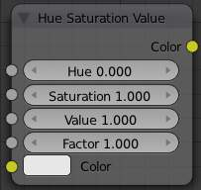
Hue Saturation Value node
Use this node to adjust the Hue, Saturation, and Value of an input.

Combine and Separate RGB
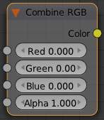
Combine RGB node
These two nodes allow you to convert between float values and color values. Colors are composed of 3 or 4 channels; red, green, blue, and sometimes alpha.
With Combine RGB, you can specify the values of each channel, and the node will combine them into a color value.
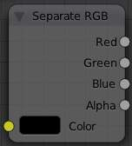
Separate RGB node
With Separate RGB, you can specify a color value, and get each channel value out of it.

Pattern Nodes

Checker
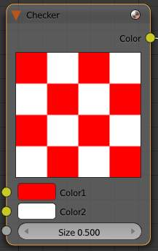
Checker node
The checker node creates a checkerboard pattern
color 1/color 2
Sets the color of the squares
Size
The scale of the checker pattern

Bricks
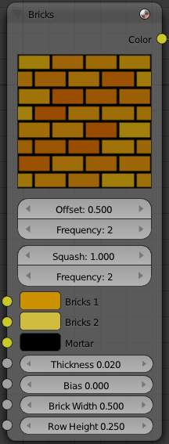
Bricks node
The Bricks node creates a brick like pattern
Offset
The relative offset of the next row of bricks
Frequency
Offset every N rows. The brick pattern offset repeats every N rows.
Squash
Scales the bricks in every N rows by this amount.
Frequency
Squash every N rows.
Bricks 1, Bricks 2
Sets the color range of the bricks. Brick colors are chosen randomly between these two colors.
Mortar
Sets the mortar color, in between the bricks.
Thickness
Sets the thickness of the mortar
Bias
The bias of randomly chosen colors, between -1 and 1. -1 Makes all bricks Color 1, and a value of 1 makes them all Color 2.
Brick Width
Sets the horizontal size of all the bricks.
Row Height
Sets the verticalsize of all the bricks.

Texture Nodes

These nodes generat procedural textures, and function just like their non node based counterparts.

Common Options
Color 1/Color 2
Remaps the procedural texture with these colors. These do not function in the Magic node.

Voronoi
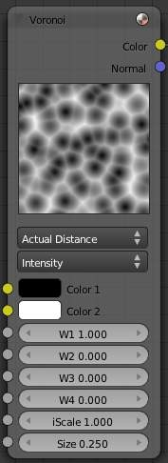
Voronoi node
See Here

Blend
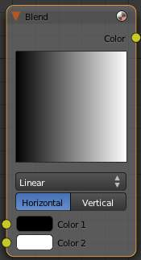
Blend node
See Here

Magic
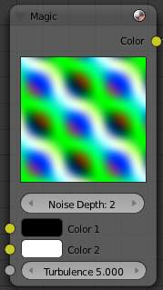
Magic node
See Here

Marble
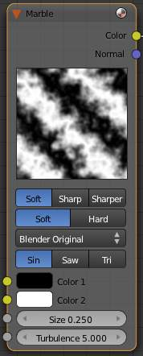
Marble node
See Here

Clouds
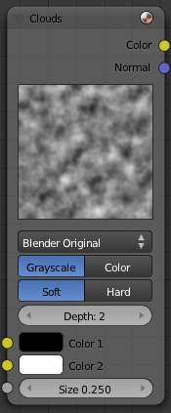
Clouds node
See Here
Wood

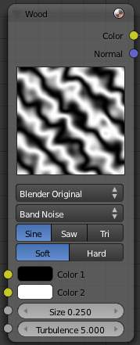
Wood node
See Here

Musgrave
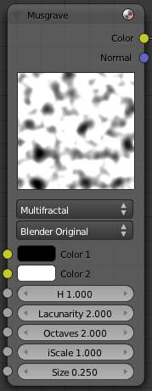
Musgrave
See Here

Noise
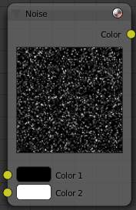
Noise
See Here

Stucci
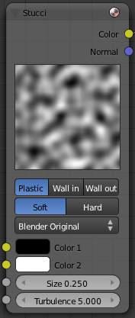
Stucci
See Here

Distorted Noise
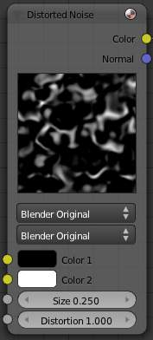
Distorted Noise node
See Here

Texture Convertor Nodes

As the name implies, these nodes convert the colors in the material in some way.
Math

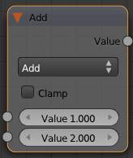
math node
The math node performs one of several math functions on one or two inputs
Clamp
Clamps the result between 0 and 1.
Add
Add the two inputs
Subtract
Subtract input 2 from input 1
Multiply
Multiply the two inputs
Divide
Divide input 1 by input 2
Sine
The sine of input 1 (degrees)
Cosine
The cosine of input 1 (degrees)
Tangent
The tangent of input 1 (degrees)
Arcsine
The arcsine (inverse sine) of input 1 (degrees)
Arccosine
The arccosine (inverse cosine) of input 1 (degrees)
Arctangent
The arctangent (inverse tangent) of input 1 (degrees)
Power
Input 1 to the power of input 2 (input1^input2)
Logarithm
log base input 2 of input 1
Minimum
The minimum of input 1 and input 2
Maximum
The maximum of input 1 and input 2
Round
Rounds input 1 to the nearest integer
Less Than
Test if input 1 is less than input 2, returns 1 for true, 0 for false
Greater Than
Test if input 1 is greater than input 2, returns 1 for true, 0 for false

ColorRamp Node
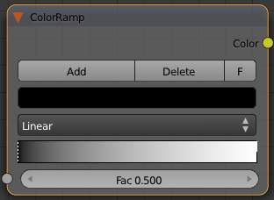
ColorRamp Node
The ColorRamp Node is used for mapping values to colors with the use of a gradient. It works exactly the same way as a Colorband for textures and materials, using the Factor value as a slider or index to the color ramp shown, and outputting a color value and an alpha value from the output sockets.
By default, the ColorRamp is added to the node map with two colors at opposite ends of the spectrum. A completely black black is on the left (Black as shown in the swatch with an Alpha value of 1.00) and a whitewash white is on the right.
See Color Ramp Widget for editing info.

RGB to BW Node
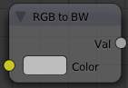
RGB to BW Node
This node converts a color image to black-and-white by computing the luminance of the rgb values.

Value to Normal
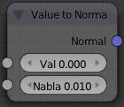
Value to Normal node
Computes a normal map based on greyscale values of an input
Val
The texture to compute the normal map from
Nabla
Size of derivative offset used for calculating normals.

Distance
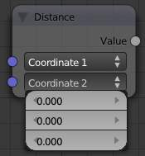
Distance node. Coordinate 2 dropdown is displayed
Computes the distance between two 3d coordinates.

Distort Nodes

These nodes allow you to change the mapping of a texture.

Rotate
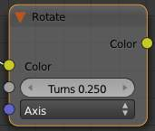
Rotate node
Rotate the texture coordinates of an image or texture.
Turns
The number of times to rotate the coordinates 360 degrees about the specified axis.
Axis
The axis to rotate the mapping about

Translate
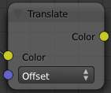
Translate node
Translate the texture coordinates of an image or texture.
Offset
The amount to offset the coordinates in each of the 3 axes.

Scale
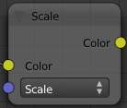
Scale node
Scale the texture coordinates of an image or texture.
Scale
The amount to scale the coordinates in each of the 3 axes.

At
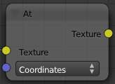
At node
Returns the color of a texture at the specified coordinates. If the coordinates are not spatially varying, the node will return a single color.
Coordinates
The point at which to sample the color. For images, the space is between -1 and 1 for x and y.

Volume Textures

Bforartists has two textures that can be applied to volumetric data:
Voxel Data
Voxel data renders a voxel source. It can be used for rendering Bforartists’s internal smoke simulations. Other sources include binary raw formats, and Image Sequence, which can be used to stack a sequence of images into a 3D representation
Point Density
Point density renders a given point cloud (object vertices or particle system) as a 3D volume
- Voxel Data
- Point Density Texture

Voxel Data

Voxel data renders a voxel source, working very similarly to an image texture, but in 3d. Various input data source types are available (such as smoke voxel data, or external files), as well as various interpolation methods.
The voxels are stored in a flat z/y/x grid of floats. Functions for sampling this based on location within the (0,1) bounds are available in:
- source/Bforartists/blenlib/intern/voxel.c
The default voxel data source, Smoke, is used for rendering Bforartists’s internal smoke simulations. Other sources include binary raw formats, and Image Sequence, which can be used to stack a sequence of images into a 3D representation, which is a common format for medical volume data such as CT scans.

Settings
File Format
Bforartists Voxel
Default binary voxel file format.
8 bit RAW
8 bit grayscale binary data.
Image Sequence
Generate voxels from a sequence of image slices.
Smoke
Render voxels from a Bforartists smoke simulation.
Source Path
The external source data file to use for 8 bit Raw data and Bforartists Voxel formats
Domain Object (Smoke)
Object used as the smoke simulation domain
Source
Smoke
Use smoke density and color as texture data.
Flame
Use flame temperature as texture data.
Heat
Use smoke heat as texture data. Values from -2.0 to 2.0 are used.
Velocity
Use smoke velocity as texture data.
Resolution
Resolution of the voxel grid when using 8 bit Raw data.
Interpolation
Nearest Neighbor
No interpolation, fast but blocky and low quality.
Linear
Good smoothness and speed.
Quadratic
Mid-range quality and speed.
Cubic Catmull-Rom
Smoothed high quality interpolation, but slower.
Extension
Extend
Extend by repeating edge pixels of the image.
Clip
Clip to image size and set exterior pixels as transparent.
Repeat
Cause the image to repeat horizontally and vertically.
Intensity
Multiplier for intensity values

Point Density Texture

Point density renders a given point cloud (object vertices or particle system) as a 3D volume, using a user-defined radius for the points. Internally, the system uses a BVH data structure for fast range lookups.
The rendered points are spherical by default, with various smooth falloff options, as well as simple Turbulence options for displacing the result with noise, adding fine detail. When using Point Density with a particle system, additional particle info such as particle velocity, age, and speed, can be visualized using a color/alpha ramp gradient.

Options
Particle System
Particle System, Generate point density from a particle system.
Object Vertices
Object Vertices, Generate point density from an object’s vertices.
Object Radius System Falloff
Standard Smooth Soft Softness
Constant
Density is constant within lookup radius.
Root Particle Age Particle Velocity Velocity Scale
Falloff Curve
Use a custom falloff
Cache
Coordinate system to cache particles in Global Space Emit Object Space Emit Object Location
Color Source
Data to derive the color results from
Constant
Constant color
Particle Age
Lifetime mapped as 0.0 - 1.0 intensity.
Particle Speed
Particle speed (absolute magnitude of velocity) mapped as 0.0-1.0 intensity.
Scale
Multiplier to bring particle speed within an acceptable range.
Particle Velocity
XYZ velocity mapped to RGB colors.
Scale
Multiplier to bring particle speed within an acceptable range.

Turbulence
Adds directed noise to the density at render time
Influence
Method for driving added turbulent noise
Static
Noise patterns will remain unchanged, faster and suitable for stills.
Particle Velocity
Turbulent noise driven by particle velocity.
Particle Age
Turbulent noise driven by the particle’s age between birth and death.
Global Time
Turbulent noise driven by the global current frame.
Noise Basis
See Here
Size
Scale of the turbulent noise
Depth
Level of detail in the added turbulent noise
Turbulence Strength
Strength of the added turbulent noise

Texture Mapping

Textures need mapping coordinates, to determine how they are applied to the object. The mapping specifies how the texture will ultimately wrap itself to the object.
For example, a 2D image texture could be configured to wrap itself around a cylindrical shaped object.

Coordinates
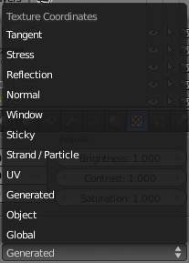
Mapping Coordinate menu
Coordinates
Mapping works by using a set of coordinates to guide the mapping process. These coordinates can come from anywhere, usually the object to which the texture is being applied to.
Global
The scene’s global 3D coordinates. This is also useful for animations; if you move the object, the texture moves across it. It can be useful for letting objects appear or disappear at a certain position in space.
Object
Uses an object as source for coordinates. Often used with an Empty, this is an easy way to place a small image at a given point on the object. This object can also be animated, to move a texture around or through a surface.
Object
Select the name of an object.
Generated
The original undeformed coordinates of the object. This is the default option for mapping textures.
UV
UV mapping is a very precise way of mapping a 2D texture to a 3D surface. Each vertex of a mesh has its own UV co-ordinates which can be unwrapped and laid flat like a skin. You can almost think of UV coordinates as a mapping that works on a 2D plane with its own local coordinate system to the plane on which it is operating on. This mapping is especially useful when using 2D images as textures, as seen in UV Mapping. You can use multiple textures with one set of UV coordinates.
Layer
Select your UV layer to use it for mapping.
Strand/Particle
Uses normalized 1D strand texture coordinate or particle age(X) and trail position (Y). Use when texture is applied to hair strands or particles.
Window
The rendered image window coordinates. This is well suited to blending two objects.
Normal
Uses the direction of the surface’s normal vector as coordinates. This is very useful when creating certain special effects that depend on viewing angle.
Reflection
Uses the direction of the reflection vector as coordinates. This is useful for adding reflection maps - you will need this input when Environment Mapping.
Stress
Uses the difference of edge length compared to original coordinates of the mesh. This is useful, for example, when a mesh is deformed by modifiers.
Tangent
Uses the optional tangent vector as texture coordinates.

Projection
Flat
Flat mapping gives the best results on single planar faces. It does produce interesting effects on the sphere, but compared to a sphere-mapped sphere the result looks flat. On faces that are not in the mapping plane the last pixel of the texture is extended, which produces stripes on the cube and cylinder.
Cube
Cube mapping often gives the most useful results when the objects are not too curvy and organic (notice the seams on the sphere).
Tube
Tube mapping maps the texture around an object like a label on a bottle. The texture is therefore more stretched on the cylinder. This mapping is of course very good for making the label on a bottle or assigning stickers to rounded objects. However, this is not a cylindrical mapping so the ends of the cylinder are undefined.
Sphere
Sphere mapping is the best type for mapping a sphere, and it is perfect for making planets and similar objects. It is often very useful for creating organic objects. It also produces interesting effects on a cylinder.

Inheriting coordinates from the parent object
From Dupli
Duplis instanced from vertices, faces, or particles, inherit texture coordinates from their parent.
Todo: explaination

Coordinate Offset, Scaling and Transformation
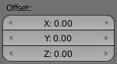
Offset panel
Offset
The texture co-ordinates can be translated by an offset. Enlarging of the Ofs moves the texture towards the top left.
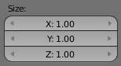
Size panel
Size
These buttons allow you to change the mapping of axes between the texture’s own coordinate system, and the mapping system you choose (Generated, UV, etcetera.) More precisely, to each axis of the texture corresponds one of four choices, that allow you to select to which axis in the mapping system it maps! This implies several points:
- For 2D textures (such as images), only the first two rows are relevant, as they have no Z data.
- You can rotate a 2D picture a quarter turn by setting the first row (i.e. X texture axis) to Y, and the second row (Y texture axis) to X.
- When you map no texture axis (i.e. the three “void” buttons are set), you’ll get a solid uniform texture, as you use zero dimension (i.e. a dot, or pixel) of it (and then Bforartists extends or repeats this point’s color along all axes.)
- When you only map one texture axis (i.e. two “void” buttons are enabled) you’ll get a “striped” texture, as you only use one dimension (i.e. a line of pixel) of it, (and then Bforartists stretches this line along the two other axes).
- The same goes, for 3D textures (i.e. procedural ones), when one axis is mapped to nothing, Bforartists extends the plan (“slice”) along the relevant third axis.
So, all this is a bit hard to understand and master. Fortunately, you do not have to change these settings often, except for some special effects... Anyway, the only way to get used to them is to practice!

Environment Maps

Environment maps take a render of the 3D scene and apply it to a texture, to use for faking reflections. If you want to achieve a very realistic result, raytraced reflections are a good solution. Environment Maps are another way to create reflective surfaces, but they are not so simple to set up.
So why should one use Environment Maps?
- The main reason is probably that they can be much faster than raytracing reflections. In certain situations they need to be calculated only once, and may be reused like any ordinary texture. You may even modify the precalculated Environment Map in an image editor.
- Environment maps can also be blurred and render even faster because the resolution can then be lowered. Blurring a reflection with the raytracer always adds to the render time, sometimes quite a lot.
- Halos (a visualization type for particles) are not visible to raytraced reflections, so you need to setup environment maps to reflect them.
- Keypoint strands (another visualization type for particles) are also not visible to raytraced reflections, so you need to setup environment maps to reflect them.
Just as we render the light that reaches the viewing plane using the camera to define a viewpoint, we can render the light that reaches the surface of an object (and hence, the light that might ultimately be reflected to the camera). Bforartists’s environment mapping renders a cubic image map of the scene in the six cardinal directions from any point. When the six tiles of the image are mapped onto an object using the Refl input coordinates, they create the visual complexity that the eye expects to see from shiny reflections.
Note
It’s useful to remember here that the true goal of this technique is believability, not accuracy. The eye doesn’t need a physically accurate simulation of the light’s travel; it just needs to be lulled into believing that the scene is real by seeing the complexity it expects. The most unbelievable thing about most rendered images is the sterility, not the inaccuracy.

Options
Important
For correct results, the mapping of an environment map texture must be set to ‘Refl’ (reflection co-ordinates) in the Map Input panel of the Material context.

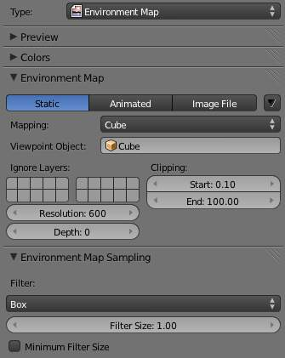
Reflecting plane EnvMap settings.
Bforartists allows three types of environment maps, as you can see in Reflecting plane EnvMap settings. :
Static
The map is only calculated once during an animation or after loading a file.
Animated
The map is calculated each time a rendering takes place. This means moving Objects are displayed correctly in mirroring surfaces.
Image File
When saved as an image file, environment maps can be loaded from disk. This option allows the fastest rendering with environment maps, and also gives the ability to modify or use the environment map in an external application.
When using planar reflections, if the camera is the only moving object and you have a reflecting plane, the Empty must move too and you must use Anim environment map. If the reflecting object is small and the Empty is in its center, the environment map can be Static, even if the object itself rotates since the Empty does not move. If, on the other hand, the Object translates the Empty should follow it and the environment map be of Anim type.
Options in dropdown menu:
Clear Environment Map
Clears the currently rendered environment map from memory. This is useful to refresh a Static environment maps and you have changed things in your scene since the last time the environment map was rendered. Anim environment maps do this automatically on every render.
Save Environment Map
Saves the currently stored static environment map to disk as an image file. This can be loaded again with Load.
Clear All Environment Maps
Does the same as Free Data, but with all environment maps in the scene. This is a useful shortcut when using recursive environment maps (when the Depth is greater than 0).
Note
EnvMap calculation can be disabled at a global level by the EnvMap Tog Button in the Render Panel of the Rendering Buttons.

Viewpoint Object
Environment maps are created from the perspective of a specified object. The location of this object will determine how ‘correct’ the reflection looks, though different locations are needed for different reflecting surfaces. Usually, an Empty is used as this object.
- For planar reflections, the object should be in a location mirrored from the camera, on the other side of the plane of reflection (see Examples). This is the most accurate usage of Environment maps.
- For spherical reflections, the object should be in the center of the sphere. Generally, if the reflecting sphere’s object center point is in the center of its vertices, you can just use the name of the actual sphere object as the Ob:
- For irregular reflections, there’s no hard and fast rule, you will probably need to experiment and hope that the inaccuracy doesn’t matter.
Ignore Layers
The layers to exclude from the environment map creation. Since environment maps work by rendering the scene from the location of the Ob: object, you will need to exclude the actual reflecting surface from the environment map, otherwise it will occlude other objects that should be reflected on the surface itself.
Eg. If you are rendering an environment map from the center of a sphere, all the environment map will show by default is the inside of the sphere. You will need to move the sphere to a separate layer, then exclude that layer from the environment map render, so that the environment map will show (and hence reflect) all the objects outside the sphere.
Resolution
The resolution of the cubic environment map render. Higher resolutions will give a sharper texture (reflection), but will be slower to render.
Depth
The number of recursive environment map renders. If there are multiple reflecting objects using environment maps in the scene, some may appear solid, as they won’t render each other’s reflections. In order to show reflections within reflections, the environment maps need to be made multiple times, recursively, so that the effects of one environment map can be seen in another environment map. See Examples.
Clipping Start/End
The clipping boundaries of the virtual camera when rendering the environment map. Sets the minimum and maximum distance from the camera that will be visible in the map.

Environment Map Sampling
Filter
Box
Box Filter
EWA
Elliptical Weighted Average - one of the most efficient direct convolution algorithms developed by Paul Heckbert and Ned Greene in the 1980s. For each texel, EWA samples, weights, and accumulates texels within an elliptical footprint and then divides the result by the sum of the weights.
Eccentricity
Maximum eccentricity (higher gives less blur at distant/oblique angles, but is also slower)
FELINE
FELINE (Fast Elliptical Lines), uses several isotropic probes at several points along a line in texture space to produce an anisotropic filter to reduce aliasing artifacts without considerably increasing rendering time.
Probes
Maximum number of samples (higher gives less blur at distant/oblique angles, but is also slower)
Area
Eccentricity
Maximum eccentricity (higher gives less blur at distant/oblique angles, but is also slower)
Filter Size
The amount of blurring applied to the texture. Higher values will blur the environment map to fake blurry reflections.
Minimum Filter Size
Use Filter Size as a minimal filter value in pixels

Examples
In this example, an empty is used as the Ob: of the reflecting plane’s environment map. It is located in the specular position of the camera with respect to the reflecting surface. (This is possible, strictly speaking, only for planar reflecting surfaces.) Ideally, the location of the empty would mirror the location of the camera across the plane of the polygon onto which it is being mapped.
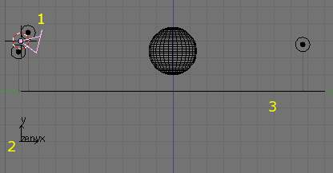  Planar reflection example. 1: Camera, 2: Empty, 3: Reflecting Plane. | 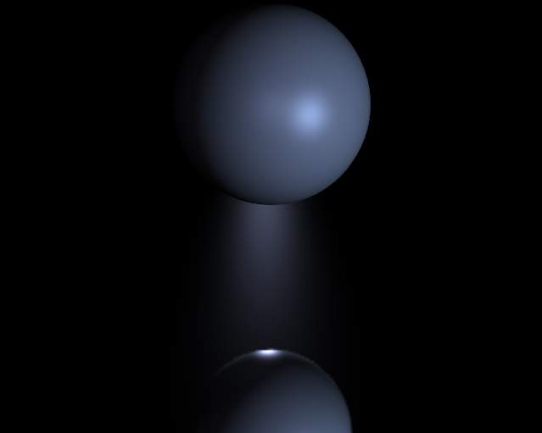  Sphere on a reflecting surface.
The following images show the effect of the Depth. The first render has depth set to 0. This means the environment map on the plane has rendered before the environment map of the sphere, so the sphere’s reflection isn’t shown. By raising the Depth, the environment map is rendered recursively, in order to get reflections of reflections.
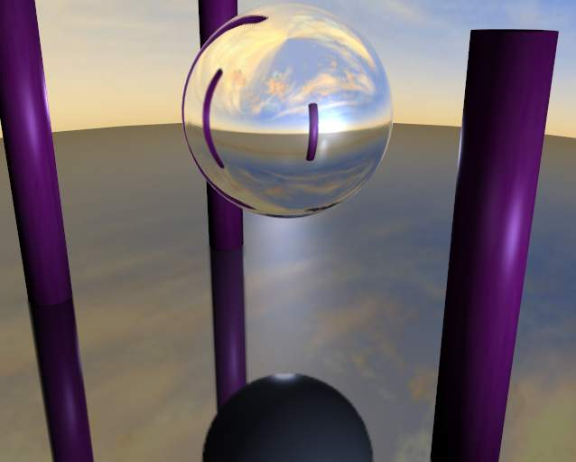  Reflecting sphere on a reflecting surface. | 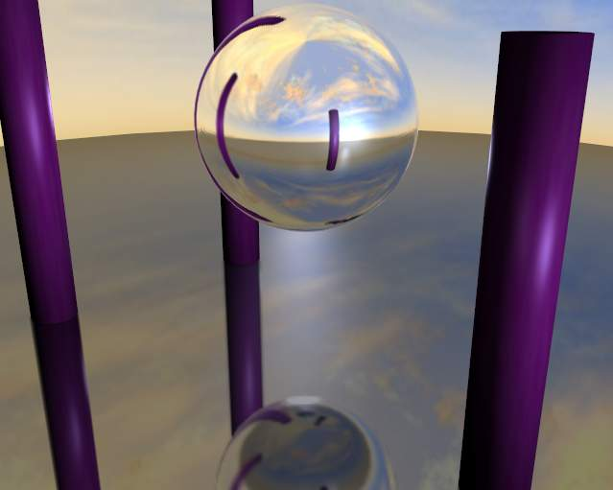  Reflecting sphere on a reflecting surface with multiple reflections.

Limitations
Because environment maps are calculated from the exact location of the Viewpoint Object’s object center, and not from actual reflecting surface, they can often be inaccurate, especially with spheres. In the following image, the rectangular prism and the smaller spheres are touching the sides of the large reflecting sphere, but because the environment map is calculated from the center of the sphere, the surrounding objects look artificially far away.
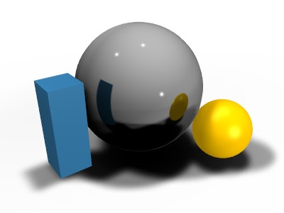
Inaccurate spherical reflection, the colored objects are artificially offset

Material Textures Influence

Not only can textures affect the color of a material, they can also affect many of the other properties of a material. The different aspects of a material that a texture influences are controlled in the Influence panel.
Note
Texture options for Surface and Wire materials and in some cases also for Volume and Halo materials.

Surface and Wire materials
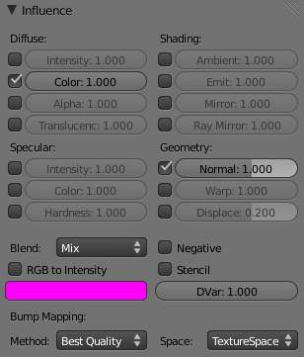
Texture Influence panel for a Surface material

Diffuse
Intensity
Amount texture affects affects diffuse reflectivity
Color
Amount texture affect the basic color or RGB value of the material
Alpha
Influences the opacity of the material. Also use Z Transparency for light and if combining multiple channels.
Translucency
Influences the Translucency amount.

Specular
Intensity
Amount texture affect specular reflectivity
Color
Influences the Specular color, the color of the reflections created by the lamps on a glossy material.
Hardness
Influences the specular hardness amount. A DVar of 1 is equivalent to a Hardness of 130, a DVar of 0.5 is equivalent to a Hardness of 65.

Shading
Ambient
Influences the amount of Ambient light the material receives.
Emit
Influences the amount of light Emitted by the material.
Mirror
Influences the mirror color. This works with environment maps and raytraced reflection.
Ray Mirror
Influences the strength of raytraced mirror reflection.

Geometry
Normal
Commonly called bump mapping, this alters the direction of the surface normal. This is used to fake surface imperfections or unevenness via bump mapping, or to create reliefs.
Warp
Warp allows textures to influence/distort the texture coordinates of a next texture channel. The distortion remains active over all subsequent channels, until a new Warp has been set. Setting the factor at zero cancels out the effect.
Displace
Influences the Displacement of vertices, for using Displacement Maps.

Other Controls
Blend
Blending operation to perform. See Texture Blending Modes for details.
RGB to intensity
With this option enabled, an RGB texture (affects color) is used as an intensity texture (affects a value).
Blend Color
If the texture is mapped to Col, what color is blended in according to the intensity of the texture? Click on the swatch or set the RGB sliders.
Negative
The effect of the Texture is negated. Normally white means on, black means off, Negative reverses that.
Stencil
The active texture is used as a mask for all following textures. This is useful for semitransparent textures and “Dirt Maps”. Black sets the pixel to “untexturable”. The Stencil mode works similar to a layer mask in a 2D program. The effect of a stencil texture can not be overridden, only extended. You need an intensity map as input.
DVar
Destination Value (not for RGB). The value with which the Intensity texture blends with the current value. Two examples:
- The Emit value is normally 0. With a texture mapped to Emit you will get maximal effect, because DVar is 1 by default. If you set DVar to 0 no texture will have any effect.
- If you want transparent material, and use a texture mapped to Alpha, nothing happens with the default settings, because the Alpha value in the Material panel is 1. So you have to set DVar to 0 to get transparent material (and of course Z Transparency also). This is a common problem for beginners. Or do it the other way round - set Alpha to 0 and leave Dvar on 1. Of course the texture is used inverted then.
Bump Mapping
Settings for bump mapping. Method Best Quality, Default, Compatible, Original Space
Texture Space, Object Space, View Space

Volume materials
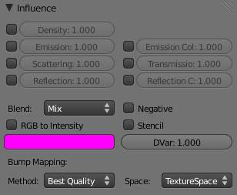
Texture Influence panel for Volume material
Special texture options for Volume materials
Density
Causes the texture to affect the volume’s density.
Emission
Causes the texture to affect the volume’s emission.
Scattering
Amount the texture affects scattering.
Reflection
Amount the texture affects brightness of out-scattered light
Emission Color
Amount the texture affects emission color.
Transmission
Amount the texture affects result color after light has been scattered/absorbed.
Reflection Color
Amount the texture affects color of out-scattered light.

Halo materials
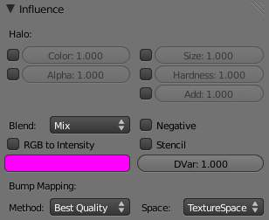
Texture Influence panel for a Halo material
Special texture options for Halo materials
Size
Amount the texture affects ray mirror.
Hardness
Amount the texture affects hardness.
Add
Amount the texture affects translucency.

Texture Blending Modes

Blending Modes are different methods of controlling how the texture influences material properties. While a blending mode defines the specific operation performed, blending factor controls the amount, the overall “strength” of this operation. For textures such blending factor is set via sliders in the Influence panel. Throughout this section, the term base layer refers to the base material color being manipulated (as defined by texture’s Influence) and blend layer refers to the texture. Following is a list of available texture blending modes:
See also
Color Blend Modes for details on each blending mode.

Bump and Normal Maps

Description
Normal Maps and Bump Maps both serve the same purpose: they simulate the impression of a detailed 3D surface, by modifying the shading as if the surface had lots of small angles, rather than being completely flat. Because it’s just modifying the shading of each pixel, this will not cast any shadows and will not obstruct other objects. If the camera angle is too flat to the surface, you will notice that the surface is not really shaped.
Both Bump Maps and Normal Maps work by modifying the normal angle (the direction pointing perpendicular from a face), which influences how a pixel is shaded. Although the terms Normal Map and Bump Map are often used synonymously, there are certain differences.
Bump maps
These are textures that store an intensity, the relative height of pixels from the viewpoint of the camera. The pixels seem to be moved by the required distance in the direction of the face normals. (The “bump” consists only of a displacement, which takes place along the existing, and unchanged, normal-vector of the face.) You may either use greyscale pictures or the intensity values of a RGB-Texture (including images).
Normal maps
These are images that store a direction, the direction of normals directly in the RGB values of an image. They are much more accurate, as rather than only simulating the pixel being away from the face along a line, they can simulate that pixel being moved at any direction, in an arbitrary way. The drawbacks to normal maps are that unlike bump maps, which can easily be painted by hand, normal maps usually have to be generated in some way, often from higher resolution geometry than the geometry you’re applying the map to.
Normal maps in Bforartists store a normal as follows:
- Red maps from (0-255) to X (-1.0 - 1.0)
- Green maps from (0-255) to Y (-1.0 - 1.0)
- Blue maps from (0-255) to Z (0.0 - 1.0)
Since normals all point towards a viewer, negative Z-values are not stored (they would be invisible anyway). In Bforartists we store a full blue range, although some other implementations also map blue colors (128-255) to (0.0 - 1.0). The latter convention is used in “Doom 3” for example.

Workflow
The steps involved in making and using Bump and Normal Maps is:
- Model a highly detailed (“hi-poly”) model
- Bake the Bump and/or Normal maps
- Make a low-poly, less detailed model
- Map the map to the low-poly model using a common coordinate system
Consult the Modeling section for how to model a highly detailed model using the Mesh tools. How much detail you put in is totally up to you. The more ridges and details (knobs, creases, protrusions) you put in, the more detailed your map will be.
Baking a map, simply put, is to take the detail of a high polygon mesh, and apply it to a similar object. The similar object is identical to the high-poly mesh except with less vertices. Use the Render Bake feature in Bforartists to accomplish this.
Modeling a low-poly using Bforartists’s Mesh editing tools. In general, the same or similar faces should exist that reflect the model. For example, a highly detailed ear may have 1000 faces in the high-poly model. In the low-poly model, this may be replaced with a single plane, oriented in the same direction as the detailed ear mesh. (Tip: Bforartists’s multi-resolution mesh modeling feature can be used to good effect here.)
Mapping is the process of applying a texture to the low-poly mesh. Consult the Textures Mapping section for more information on applying a texture to a mesh’s material.Special considerations for Bump and Normal Maps is:
- When using a Bump map, map the texture to Normal and enable No RGB.
- When using a Normal map, map the texture to Normal.
The coordinate systems of the two objects must match. For example, if you bake using a UV map of the high-poly model, you must UV map the low poly model and line up its UV coordinates to match the outline of the high-poly image (see UV unwrapping to line up with the high-poly map edges.

Displacement Maps

Description
Displacement mapping allows a texture input to manipulate the position of vertices on rendered geometry. Unlike Normal or Bump mapping, where the shading is distorted to give an illusion of a bump (discussed on the previous page), Displacement Maps create real bumps, creases, ridges, etc in the actual mesh. Thus, the mesh deformations can cast shadows, occlude other objects, and do everything that changes in real geometry can do, but, on the other hand, requires a lot more vertices to work.

Options
In the Influence panel, the strength of the displacement is controlled by the Displace and Normal sliders.
- If a texture provides only normal information (e.g. Stucci), vertices move according to the texture’s normal data. The normal displacement is controlled by the Normal slider.
- If a texture provides only intensity information (e.g. Magic, derived from color), vertices move along the directions of their normals (a vertex has no normal itself, it’s the resulting vector of the adjacent faces). White pixels move outward in the direction of the normal, black pixels move in the opposite direction. The amount of displacement is controlled with the Displace slider.
The two modes are not exclusive. Many texture types provide both information (Clouds, Wood, Marble, Image). The amount of each type can be mixed using the respective sliders. Intensity displacement gives a smoother, more continuous surface, since the vertices are displaced only outward. Normal displacement gives a more aggregated surface, since the vertices are displaced in multiple directions.
The depth of the displacement is scaled with an object’s scale, but not with the relative size of the data. This means if you double the size of an object in object mode, the depth of the displacement is also doubled, so the relative displacement appears the same. If you scale inside Edit Mode, the displacement depth is not changed, and thus the relative depth appears smaller.

Hints
Displacement maps move the rendered faces, not the physical mesh faces. So, in 3D View the surface may appear smooth, but render bumpy. To give a detailed surface, there has to be faces to displace and have to be very small. This creates the trade-off between using memory and CPU time versus render quality.
From best to worst, displacement works with these object types using the methods listed to control the render face size:
Subdivision Surface Meshes
Rendered face size is controlled with render subsurf level. Displacement really likes smooth normals.
Manually ( Edit Mode ) subdivided meshes
Control render faces with number of subdivides. (This can be combined with the above methods). Displaces exactly the same Simple Subsurf, however the overhead of drawing extra faces can slow down editing.
Meta Objects
Control render faces with render wiresize. Small wire == more faces.
The following are available, but currently don’t work well. It is recommended that you convert these to meshes before rendering.
Open NURBS Surfaces
Control render faces with U/V Surface Resolution. Higher numbers give more faces. (Note normal errors).
Closed NURBS Surfaces
Control with Surface Resolution controls. (Note the normal errors, and how implicit seam shows).
Curves and Text
Control with Surface Resolution controls. Higher gives more render faces. (Note that the large flat surfaces have few render faces to displace).
Note
Displace Modifier
If you want more control over your displacement, you’ll probably want to use the Displace Modifier. This feature has lots of different options so that you can customize the displacement exactly to your liking.

World

TODO: https://developer.Bforartists.org/T46363

Particles

TODO: https://developer.Bforartists.org/T46363

